**Task 5 , Date : 16/1/25**

1. Query the *Name* of any student in **STUDENTS** who scored higher than  *Marks*. Order your output by the *last three characters* of each name. If two or more students both have names ending in the same last three characters (i.e.: Bobby, Robby, etc.), secondary sort them by ascending *ID*.

**Input Format**

The **STUDENTS** table is described as follows:

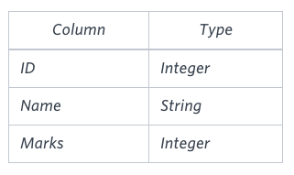

**Solution :** Select Name from STUDENTS where Marks > 75 order by Substring(Name,-3), Id asc;

1. Write a query that prints a list of employee names (i.e.: the *name* attribute) from the **Employee** table in alphabetical order.

**Input Format**

The **Employee** table containing employee data for a company is described as follows:

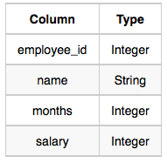

where *employee_id* is an employee's ID number, *name* is their name, *months* is the total number of months they've been working for the company, and *salary* is their monthly salary.

**Solution:** select name from Employee order by name asc;

1. Find the difference between the total number of **CITY** entries in the table and the number of distinct **CITY** entries in the table.  
   The **STATION** table is described as follows:

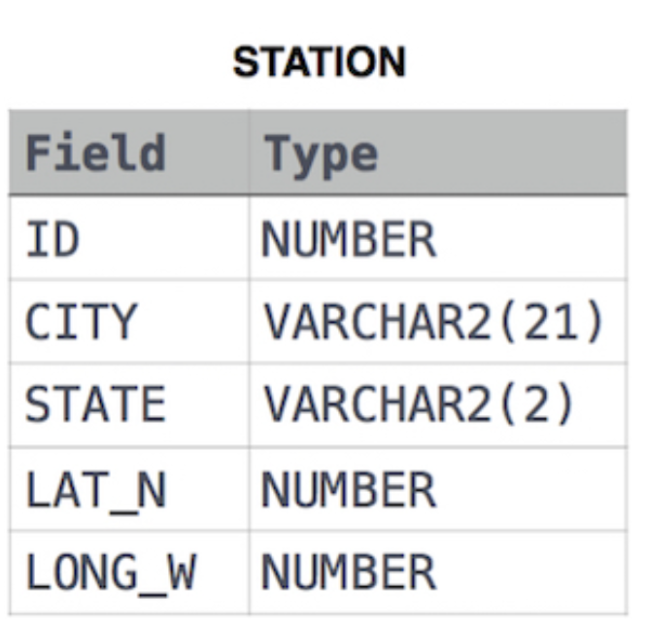

where **LAT_N** is the northern latitude and **LONG_W** is the western longitude.

For example, if there are three records in the table with **CITY** values 'New York', 'New York', 'Bengalaru', there are 2 different city names: 'New York' and 'Bengalaru'. The query returns , because

**Solution :** Select (count(CITY) - count(distinct CITY)) as difference from STATION

1. Write a query that prints a list of employee names (i.e.: the *name* attribute) for employees in **Employee** having a salary greater than  per month who have been employees for less than  months. Sort your result by ascending *employee_id*.

**Input Format**

The **Employee** table containing employee data for a company is described as follows:

**Solurtion :** Select name from Employee where salary > 2000 and months < 10

order by employee_id Asc ;